***Warriors Win Back*** 2 ***Back CSL North Conference Championships***

1

2013 **Deerfield Champions**

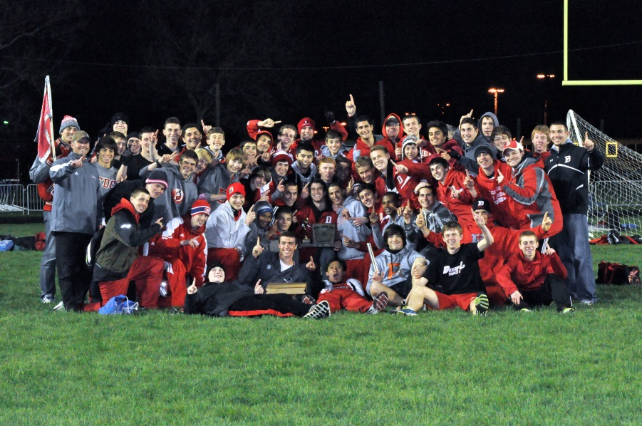



On Friday May 10th the 212 Deerfield Warriors traveled to Maine West HS for the 2013 CSL North Conference Championships. The Warriors came in to the meet as the defending champions after breaking a 7 year stretch of runner up finishes to Niles North last year. After losing one of the most decorated Track & Field Senior Classes in school history this years group knew from that 1st day in January that hard work, patience, and having a clear vision not on what we were early in the season, but what we know we could become in MAY. *That vision and GOAL to defend our title happened on Friday night as the Warriors won their 2nd straight CSL North Conference Championship with 141pts over a tough Highland Parks 113pts, Niles Norths 108pts, Maine Easts 82pts, Maine Wests 60pts, and Glenbrook Norths 48pts to start a streak of their own!* What a moment for all the athletes, parents, and coaches who have worked as one to help the TEAM complete this journey. We all do our best so the boys can do their best and they sure did as the 212 Philosophy, our focus on Character, Training, Competing (CTC), and the TRADITION of what it means to wear the BLOCK D on your chest were all on display on

the Track and in the Field. YOU BOILED UP Varsity. Congrats!

The Frosh/Soph also had an unbelievable evening as they had 5 of their teammates pulled up to Varsity and still scored 111pts to finish 3rd behind Glenbrook Norths Championship effort of 156pts, Niles Norths 119pts, and ahead of Maine Easts 71pts, Highland Parks 70pts, and Maine West 27pts. There is no doubt watching this young group of Warriors that the foundation for a very fun next few years is there in all areas. They love to get in the fight and stay in the fight meet in and meet out.

Awesome Job Frosh/Soph!

*Key motivating experiences are special and this was one night where all our levels had them, earned them, and hopefully cherish them for many years to come. Congrats Warriors!

*Special Mention has to go to Alex Gold as he is now 5th All Time at DHS in the 3200m with a time of 9:09.13*

*Special Mention also goes to the 4x100 Relay of Brett Freedberg, Jacob Balder, Donald Middlebrook, and Michael Lee as they are 1st 4x100 relay to win the CSL North Conference Title under the current Staff and that broke a 13 year run of Niles North victories in that event as well. WOW!*

**The following Warriors placed at the 2013 CSL NORTH Conference Championships:**

**Varsity:**

4x800R-2nd Charles Nash, Max Rich, Evan Linton, Jordan Abosch

*4x100R-Champions-Brett Freedberg, Jacob Balder, Donald Middlebrook, Michael Lee*

*3200m-Champion-Alex Gold*, 5th Shai Farhi

110HH-2nd-Chris Douglas, 6th-Jack Sherman

100m-3rd-Brett Freedberg, 6th-Jacob Balder

*400m-Champion-Donald Middlebrook*

*300IH-Champion-Chris Douglas*, 5th-Matt Pigott

*1600m-Champion-Alex Gold*, 5th Jordan Abosch

200m-2nd-Donald Middlebrook

4x400R-3rd-Patrick Brunk, Chris Douglas, Evan Linton, Charles Nash

*SP-Champion-Dominic Dibenedetto*

Discus-3rd-Casey Spiwak, David Lebovitz

HJ-5th-Charlie Kogan

*PV-Champion-Donald Middlebrook*, 5th-Brett Freedberg

LJ-2nd-Alex Williams, 5th-Connor Oriot

TJ-3rd-Charlie Kogan

**Frosh/Soph:**

4x800R-4th-Zach Molina, David Bickmore, James Sanford, Alex Wolfe

4x100R-2nd-Jon Sciarretta, Kyle Oldham, Andrew Balder, Zach Shaltiel

3200m-5th-Billy Anderson

110HH-3rd-Hank Flury

100m-4th-Kyle Oldham, 5th-Jon Sciarretta

*800m-Champion-Jeremy Latronica*

4x200-2nd-Zach Shaltiel, Andrew Balder, Kyle Oldham, Will Boshes

300IH-5th-Dean Scopelliti, 6th-Hank Flury

1600m-5th-Jeremy Latronica

200m-5th-Kyle Oldham, 6th-Jon Sciarretta

4x400R-5th-Zach Molina, Billy Anderson, Alex Wolfe, Jeremy Latronica

SP-3rd-John Phipps, 6th-Graham Tonner

*Discus-Champion-Graham Tonner*, 2nd-John Phipps

HJ-3rd-Will Boshes, 6th-Hank Flury

*PV-Champion-Blake Welter*, 2nd-Justin Wilde

LJ-5th-Jacob Schurgin, 6th Andrew Balder

TJ-4th-Will Boshes





**The following Warriors Are CSL North ALL-CONFERENCE:**

**Varsity:**

Dominic Dibenedetto

Chris Douglas

Brett Freedberg

Alex Gold

Charlie Kogan

Donald Middlebrook

Alex Williams

*TBA: Casey Spiwak*

**Soph:**

Will Boshes

Hank Flury

Jeremy Latronica

John Phipps

Kyle Oldham

Graham Tonner

Blake Welter

Justin Wilde

**Frosh:**

Andrew Balder

David Bickmore

Hank Flury

Caleb Leman

Jacob Schurgin